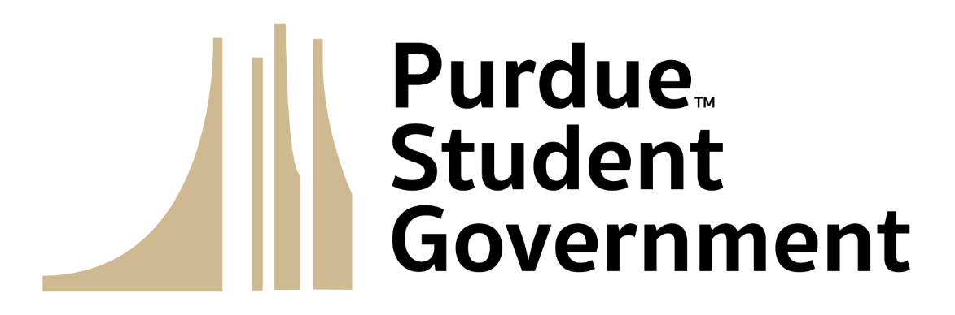
Purdue Student Senate
Session 4
August 23, 2023

- Special Programming
- Call to Order
  - Proxy Reports
  - Roll Call
  - Introduction of Visitors
  - Land Acknowledgement
  - Pledge of Purpose
  - Approval of Minutes
- Executive Reports
  - Cabinet Reports
  - Standing Committee Reports
  - Ad Hoc Committee Reports
  - Advisor Reports
- Informal Discussion
- Old Business
- New Business
  - Bill 23-11 “Legislative Appointment: Parliamentarian, Nicholas Neuman”
  - Bill 23-12 “Ad-Hoc Committee Renewal: Black Boilermaker Experience”
  - Bill 23-13 “2023-2024 Budget”
- Announcements
- Adjournment

